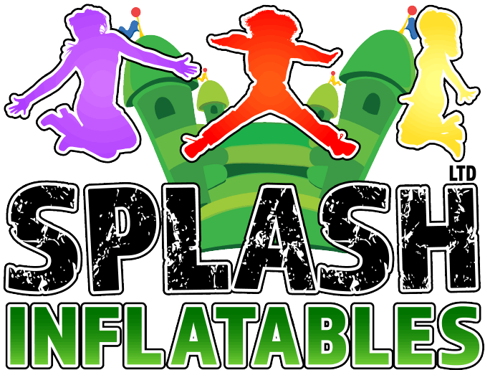 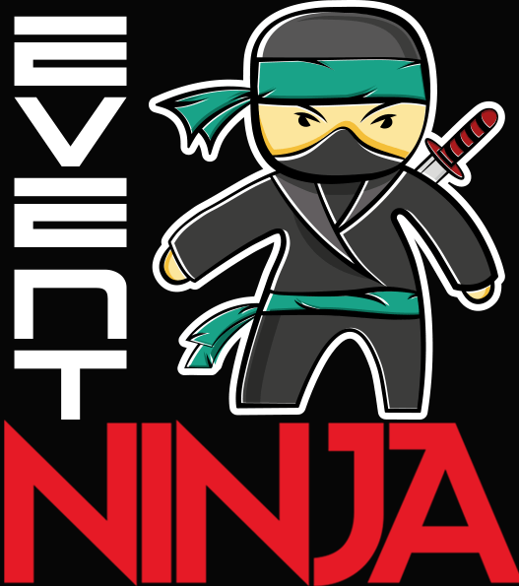 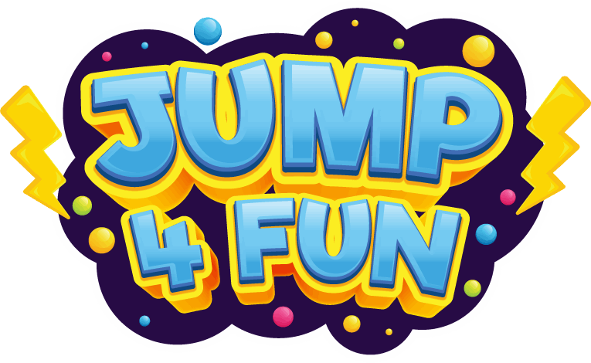

**These are the Terms and Conditions which govern the hire of all Splash inflatables Ltd T/C’s, Splash Inflatables, Event Ninja, Jump4fun Inflatables and Kidaround. Please read these carefully as you will be required to sign them prior to any hire to confirm that you acknowledge and accept these Terms and Conditions.**

**Splash Inflatables / Event Ninja / Jump4fun accepts no responsibility or liability for loss, damage or injury resulting from our customer’s negligence, however caused, which has arisen from the Customer’s non-compliance to the Terms & Conditions, safety notices and other information supplied in advance to the customer by Splash Inflatables and/ or Event Ninja and/ or Jump4fun and or/ Kidaround0**

**IF YOU ARE UNSURE OF ANYTHING, PLEASE CONTACT US ON**

**0141 370 1986**

1. **Introduction**
2. **Siting of inflatables**
3. **Access to venue or gardens**
4. **Supervision and Operation of inflatables**
5. **Power supply**
6. **Cancellation & weather policy**
7. **Mascot hire**
8. **Food machines**
9. **Damage to company equipment**
10. **Disclaimer**

**References in this document**

**“The company”**  is referenced to as Splash Inflatables Ltd / Event Ninja and Jump4fun Inflatables

**“The customer”**  is referenced to the person, company or organisation who has hired the equipment

**“Supervisor”** is referenced to the person who is responsible for supervising a particular piece of equipment. This can sometimes be ourselves, “The company” or “the customer” . The customer will be the designated supervisor unless stated in the customer quote and hire documentation.

**“The operator”**  is referenced to the person from the company who is responsible for setting up the equipment.

**1.0 INTRODUCTION**

This document is designed to provide guidance for events hiring / using play inflatables. Inflatable play is normally a very safe and good way for adults and children to exercise whilst having fun. It is important that you understand the risks and operational instructions for the safe use of the equipment before use.

**2.0 Siting of Equipment:** The siting and erection of the equipment shall be carried out by the company operator.

**2.1 Anchorage:** Even in non-windy conditions the inflatable will move and creep (Perhaps taking it dangerously close to the blower). The device should be secured to the ground with stakes, where the ground is suitable. Alternatively, if on a hard standing surface methods such as sand bags, attaching the ropes to fittings already in the ground or using pin bolts can be used to attach to a suitable hard surface. Indoors, an inflatable will have sandbags on certain points to stop the inflatable from slipping on the floor.

2.2 **Siting of the Inflatable:** The company needs to insist that the device is sited well away from overhead power lines or other obstacles such as fences. If the ground surface is abrasive, oily or dirty, a ground sheet should be used to prevent damage.

2.3 **Siting of the Inflatable:** Inflatables must be sited in a place where the company can safely drive their van to the required location without causing any obstruction or safety issues. There must not be excessive mud or any indication that their van will be stuck on grass or mud. A financial charge of expenses may be charged to the customer for the damage to vehicles or equipment/loss of earnings which has been caused by the requirement of driving/parking on unsuitable ground. We will also not be responsible for any damage caused to grass or surfaces while hiring our equipment. This is at the customer’s risk. If the customer does not provide a suitable and safe entry and/or erection site for the equipment, the company reserves the right to withdraw from the erection of the equipment and the full balance will still be due to be paid to the company.

2.4 **Site entry :** All narrow entries of less than 1m must be reported to the company before hire. Any slopes, stairs or entry obstructions must be reported before the hire. The company may ask for photos of the site entry and erection site. We will not be responsible for the damage of any property obstructing our entryway or if we need to maneuver equipment through a building. We need to be aware of distances longer than 10m from where we will park our vehicle as our equipment is heavy and cumbersome.

2.5 **Agreed set up location:** The site of the erection of the inflatables will be agreed prior to the event, and there cannot be any changes to this agreement on the actual day of hire unless safe to do so and at the operators discretion. . We will have in advance prepared our staff and equipment based on any information which you have given us at the time that you made the order. It is the responsibility of the customer to ensure the site is clear and the agreed space is available for set up with no obstructions.

2.6 If we get to your venue and we cannot fit into the site you have prepared for us, the hire amount will still be due. It is your responsibility to ensure that the site is big enough to safely fit the items that you have chosen and there are no dangerous objects surrounding.

**3.0** **Access times to venue or garden:**

3.1: We need a very minimum amount of access time to your venue or garden to allow for any delivery delays outside our control. Depending on the time of year and how busy we are, we will ask for a minimum of 1 or 2 hours access time. There are more specific details on our website. If for any reason we can not gain access to the venue or garden at the agreed times, there could be substantial delays to your delivery as our driver may not be able to wait. This may result in your items being set up late or not at all depending on the schedule set out for the vehicle on that day.

**4.0 Supervision of equipment and participants:**

4.1 **“Supervisor”** is referenced to the person who is responsible for supervising a particular piece of equipment. This can sometimes be ourselves, “The company” or “the customer” . The customer will be the designated supervisor unless stated in the customer quote and hire documentation.

4.2 Supervisors needed to ensure safe operation of the equipment. When determining the number of participants allowed on an inflatable at any given time, the customer needs to consider the age of the users, the number of people using the equipment and the environment in which the inflatable is being used. On each safety certificate for an individual inflatable, there will be a recommended number of users based on their height. All inflatables have a minimum and maximum user height requirement.

4.3 **Unsafe Users**: Person(s) supervising need to watch the activity constantly and should use a whistle or other signal at the first sign of any unsafe behaviour such as somersaults or rough play. In the case where a child is behaving dangerously, they should be asked to exit the inflatable and no longer be able to participate. If he/she will not comply to exit the inflatable, you may be forced to remove the other participants and stop use until the situation is dealt with and there is no longer a safety issue with the unruly user.

4.4 **Splash Inflatables staff will guide you** as to how to use your equipment safely and all safety questions you have must be asked prior to you using the equipment. You must also read all relevant safety documentation in regards to each item that you hire. This information can be found in the tabs on each individual website page for each individual item. If you do not see this information, please ask a member of our staff to provide this for you. Please ensure that you have read the risk assessments and all the potential hazards and supervision requirements for each piece of equipment on your order.

4.5 At all events regardless of who is the designated supervisor, the customer must have a responsible contact on site to liaise with and manage unruly participants and/or any other safety concerns. . Any supervision carried out by the company must be supported by the customer to ensure the safety of all company staff and participants. If company staff are threatened or abused by any participant or guardian, the company reserves the right to terminate the use of the equipment at any point.

4.7 **First Aid:** Not all company staff are trained in first aid. It is the customers responsibility to ensure that there is appropriate first aid available on site at their event however company staff will do their best to assist any first aid personnel.

4.8 Company supervisors take no guardianship responsibility for any participants at the event. Each child must have a responsible parent or guardian present at all times.

4.9 **General supervision guidance & method of operation:**

Person(s) supervising should ensure that users are admitted in a controlled and safe manner by following some simple guidelines:

Please ensure that you have read the risk assessments in relation to your hire. This is important as they cover all the individual risks for individual pieces of equipment. These can be requested from us or can be found online here:

https://drive.google.com/drive/folders/1XLWmLleMYouU7VVpoRH3hEbaBBhrdBkQ?usp=sharing

1. Splash Inflatables Ltd is insured for Public Liability risks in the event of damage caused to the customers, their guests, or their property, whilst using the equipment, if the operation and safety instructions given to the customer are adhered to at all times.

2. The equipment has a height and number limit of use. This information can be found on the individual annual safety certificate and also on the unit itself. The equipment has a limit of age 16 unless otherwise stated. This information can usually be obtained on the tabs on the individual website page for that item.

3. A responsible adult over 18 years must supervise the equipment at all times. Some items are required by our insurance to be supervised by a company member and this will be discussed with you before your hire.

4. No food, drinks or chewing gum may be allowed on or near the equipment to avoid choking and mess. Dirty equipment may incur a cleaning charge by the customer.

5. Ensure users are clothed appropriately. All shoes, spectacles, jewellery, badges etc. must be removed before using the equipment. Make sure there is nothing dangerous that could fall out of a child’s pocket.

6. No face paints, party poppers or silly string to be used on or near the equipment. 7. No smoking or barbeques near the equipment.

8. Climbing, hanging, summersaults or sitting on walls is DANGEROUS and must not be allowed.

9. Always ensure that the equipment is not overcrowded. It is best to avoid large and small users from using it at the same time. Ensure children don’t behave in a manner likely to injure themselves or cause distress to others.

10. No pets, toys or sharp instruments on or near the equipment.

11. If the equipment is not being used for any part of the day, please switch the equipment off at the mains.

12. Do not allow anyone to bounce on the front safety step as a user could easily bounce off the inflatable and be injured. The step is there to assist users in getting on and off.

13. Ensure no-one goes on the equipment with a history of back or neck problems or a user who is feeling unwell or who is pregnant.

14. Do not allow anyone to be on the equipment during inflation or deflation as this is DANGEROUS.

15. Do not move or re-site the inflatable after being set up by Splash Inflatables Ltd.

16. In the event of rain, the equipment must not be used and, with heavy rain, the equipment should be switched off at the mains. After, any wetness can be dried off with a towel.

16. In the event that the blower stops working:

• please ensure all users get off the inflatable immediately

• Check that the blower tube or deflation tube has not come undone or something is obstructing the blower.

17. In the event that the equipment overheats, or loses power:

• Switch the blower off at the mains then switch it back on again 1 or 2 minutes later and it should restart.

• If it does not restart, inform us straight away.

18. No persons who are visibly intoxicated may be permitted to use the equipment.

19. In the event of high winds on or over 24mph, remove any children from the inflatable and switch off until winds reduce. Wind can be extremely dangerous and can lift inflatables.

20. Make sure the blower is at least 1.2 metres from the inflatable

21.0 IMPORTANT! Ensure that an area of at least 6 feet (2 metres) around the equipment is completely safe and clear at all times.

4.10 **Crowd Control.** We, the company, do not take responsibility for crowd control at your event. We do not, as standard supply barriers and do not monitor or manage crowds. This would be the responsibility of the customer.

**5.0 Power supply**

5.1 Please ensure that your venue can accommodate the power supply required for your chosen items. This information can be found in the tabs on each individual website page for each individual item. If this information can’t be seen or read, please contact the company for detailed power requirements. We, the company, will not be responsible for any damage to electric wiring systems. All company equipment is PAT tested annually and visually inspected before hire. Please do not link more than 1 electrical extension or have extension reels wrapped tightly, the cables must remain loose to avoid them overheating and causing a risk of fire or damage to electrical units.

5.2 **Power requirements:**

We will be required to plug into a power supply at your venue. We bring 20m cables with us as standard. We do however have cables for up to 50m which we can bring upon request for an additional £3 per inflatable.

The plugs we have are standard plugs that you would see on any household 3 prong plug. Some inflatables take more than one fan therefore they may need additional plug sockets for power. Feel free to ask our staff the exact amount of plug sockets required for your hire.

Our fans which blow up the inflatables range from 0.75kw to 3kw power usage each. For example a small ball pool fan will require 0.75kw in supply and a standard bouncy castle/unit fan will run on 1.5kw and some of our much larger units run on 3kw fans. It can be important to note this as your building will need to be able to withstand the amount of power required for your chosen items.]

Some inflatables have 2 fans to run them, therefore need at least 1.5kw x 2 power supply. All assault courses come in 2 parts and therefore run on 2 x 1.5kw fans.

5.3 **Generator Power.** If you have chosen to hire our generator power, there will be no need to ensure a power supply at your venue.

5.4 **Cable Covers.** We, the company, do not supply trunking cover for our extension cables, therefore this is the responsibility of the customer to ensure that there is a safe pathway for our cables to run and/or provide cover or tape to secure the cables to ensure they are not a trip hazard.

**6.0 CANCELLATIONS & Weather policy**

**6.1 Weather conditions:** Inflatables should not be used in excess of the maximum safe wind speed specified by the manufacturer. The industry recommends a maximum wind speed 30-38kph (19- 24mph). Weather forecasts can be obtained from the Meteorological Office. If wind becomes a concern, inflatables must be deflated until safe to operate. If the wind speed picks up, and Splash Inflatables staff are not in attendance, it is the responsibility of the customer to contact Splash Inflatables to discuss the situation. If there is an immediate concern regarding excessive wind, or in an emergency, all users must leave the inflatable and the power source should be switched off. An anemometer should be on site in order to measure wind speeds and if the customer is the designated safety supervisor, then the customer should use this to measure the wind speed and record ongoing wind speeds.

6.1 We constantly monitor wind speeds and the weather to ensure that we abide with HSE guidance and comply with health and safety law. We will be in touch with you if the weather forecast is showing conditions that are likely to impact your hire. HSE set out some very clear thresholds for wind and we can not under any circumstances operate against HSE guidance. The safety of you and your family are our number 1 priority. Our insurance policy also mirrors the HSE guidance.

*Please note that we recommend that you take out party/event insurance or you can protect yourself against any potential cancellation fees by taking out our* [*Cancellation, Postponement & Damage Fee Waiver*](https://www.splashinflatables.com/pages/cancellation-and-damage-waiver)

**Cancellations by the company due to weather warning or adverse weather conditions.** The company may have to cancel in advance of the hire because of severe weather conditions. (1) Wind on or exceeding 24mph or (2) A Met Office warning due to rain or storms. Either of which in the area of the hire and at the hire times. We take into consideration wind forecasts, wind readings and also wind gust forecasts. We reserve the right to reduce the wind speed mph threshold depending on the particular circumstances of the hire for example how open to the elements that the site is, the quality of the surface and any other safety factors which would be included in our on-site risk assessment.

**If we need to cancel due to strong wind forecast or a weather warning for rain, you would have the following options:**

1) Reschedule your order to a future date and keep all credit on the order within 12 months.

2) Have 75% of the hire amount refunded back to you.

**If we come to your venue and can't set up due to adverse weather conditions you have the following options:**

1) Reschedule your order to a future date within 12 months and keep 75% credit on the order.

2) Have 50% of the total hire amount refunded back to you.

**If we come to your venue, set up and if the weather changes or you have partial use of the equipment:**

* No refund or reschedule due
* 10% off your next order

**Cancellations by the customer at least 10 days before the event.** The customer can reschedule their booking to another date within 12 months and any payment already made would carry forward to that new booking. If the customer chooses not to re-schedule, the initial payment (50% booking fee) would be lost but the rest of the payment would be refunded.

**Cancellations by the customer less than 10 days before the event but more than 3 days before** **it, due to the rain forecast.** If the reason for the cancellation is a forecast of rain (specifically a 70% forecast of rain during the event times as forecast by the Met Office) then, the customer can reschedule their booking to another date within 6 months and any payment already made would carry forward to that new booking. If the customer chooses not to re-schedule, the initial payment (50% booking fee) would be lost but the rest of the payment would be refunded.

**Cancellations by the customer less than 10 days before the event but more than 3 days before** **it, due to any other reason.** If the rain forecast criteria is not met or the booking is being cancelled for any other reason, the initial payment (50% booking fee) would be lost.

**Cancellations by the customer less than 3 days before the event.** If the booking is cancelled for any reason less than 3 days before the event, then there will be no refund of any part of the payment.

**Cancellations in the rare occurrence that the company cannot fulfil the agreed services.** This may be due to a company fault or a company error. Any money paid by the customer will be fully refunded.

On the rare occasion that the equipment that you have hired becomes unsafe to hire and/or becomes damaged, in need of a deep clean, we may need to change the equipment to another item of equal or higher value. This can sometimes happen at the last minute as equipment is hired out daily. We have a wide range of excellent equipment so it would be highly likely that we would have a very good replacement for you. If for any reason that we couldn’t replace the item for another a full refund would be given.

**Booking Fees Explained:**

Any booking fee taken is a booking fee and not a deposit. The fee is to cover administration costs for creating your order and for reserving the item/s for you. This is not a returnable deposit. The amount will be credited to your order and taken off your bill. 10 days prior to the hire you will be asked to pay the remaining amount owed which will be the hire amount minus any booking fee made.

**Refunds:**

Please note that refunds will be made back via the same method as they were paid. Debit or Credit card refunds can take up to 3-5 days to process.

**Payments:**

By default, full payment is due 10 days prior to the day of the hire itself, unless otherwise agreed prior to the hire in writing. If you intend to pay via cheque or bank transfer, you must state this at the time of booking and agree on your payment date. Late payments after the agreed date will incur a charge of £5/day late fee charge. If you have not paid for your hire and cancel, cancellation fees will still be due.

#### Zero Tolerance to Abusive Behaviour:

A zero tolerance policy towards violence and aggression is expected throughout our service. No member of staff should be subjected to violent, threatening and abusive behaviour. Our employees have the right to work and carry out their duties in an environment free from violence, threatening or abusive behaviour. This policy supports the Corporate Health and Safety Policy and the Health and Safety Risk Assessment Policy. All employees have the right to be treated with consideration, dignity and respect. If our staff feel threatened in any way, we reserve the right to discontinue all verbal communication with the customer. The customer in this case is able to continue the conversation via email if they are able to do so in a non abusive way.

Abusive is defined as **verbally threatening, using foul language, and emotionally out of control**.

**7.0 Terms and Conditions for all Mascot Hires**

Mascot costumes are cleaned before each new hire, however some stains and minor damage does become apparent over time. Each costume is in slightly different condition and age. We endeavour to hire the costumes out in excellent, very good and good hireable condition. We try to gauge our pricing for hire, usually reflecting the age and condition of the costume. Please note the condition of your costume/s when you receive it and ensure that you return the costume in the same condition as it was given to you.

Please check over your costume at your collection. Any issues must be reported to us within 4 hours of collection. Any problems with your costume please call us on 0141 370 1986 or 07515695973 or email the office [info@splashinflatables.com](mailto:info@splashinflatables.com)

Please read the following carefully:

* Please check the size of the mascot costume will fit the person who will be wearing it. Wearing a costume too small will tear the zips and seams.
* The mascot costume/s are not to be worn outside in wet or very dirty conditions.
* The mascot/s must be returned in the same condition as supplied. If it is soiled or damaged, the customer will be expected to pay an additional cleaning fee.
* Please return the mascot on the agreed day between 9am & 4.30 pm. Mascots(s) which are not returned on the agreed date (unless otherwise agreed) will incur a fee of £10 per day until the mascot is returned to us.
* By agreeing with company terms and conditions you are agreeing that if the costume is beyond repair and deemed to be a total loss then the full amount to replace the costume is payable by you/the customer.
* Splash Inflatables are not responsible for any injuries caused to any persons whilst wearing the costume on hire. Please be careful when walking and dancing around as you could trip or fall, ensure the space is clear from hazards.
* Strictly no smoking cigarettes in or near the costumes. No eating while wearing the costumes, no running races or participating in sports.
* No face-paints or glitter to be used near the mascot costume or be worn by the mascot wearer as it can permanently stain the equipment.

**8.0: Food Machines**

**8.1: Candy Floss Machines**

1. Position your assembled Candy Floss Machine on a flat surface or table close to a plug socket and make sure that the non-slip rubber feet are secure on the surface.

2. Plug the power lead into a suitable plug socket.

3. Switch the machine ON and wait for about 3 minutes for the spinner to heat up to the correct temperature. Do not touch this part as it will get very hot.

4. Switch the machine OFF after 3 minutes and wait for the spinner to stop spinning.

5. Measure out one scoop of sugar using the measuring spoon included and carefully pour into the center of the spinner.

6. REMEMBER that the spinner becomes hot; do not touch this with your hands.

7. Switch ON the Candy Floss Maker, and after a few minutes you will be able to see a candy floss web being formed. In a quick motion move a paper cone or wooden stick in a clockwise motion around the spinner. Keep twisting until a candy floss layer has formed around the cone or stick.

8. Once the first layer has been formed, hold the cone or stick horizontally over the machine. Keep twisting the paper cone or stick with your fingers.

9. Once the machine stops producing candy floss, this indicates that all of the sugar has been melted. Switch OFF the Candy Floss Maker and wait for the spinner to stop spinning.

10. Your candy floss is now ready to eat.

11. To make more candy floss simply add more sugar using the measuring scoop to the centre of the spinner and repeat the process.

When using your Candy Floss Maker, the standard safety precautions listed below must be followed.

1. Read all instructions carefully before using the appliance and retain this user guide for future reference.

2. Do not operate this appliance if the base unit, cable or mains plug are showing any sign of damage.

3. This appliance should not be assembled or operated by children.

4. Do not touch the Spinner with your fingers during or after use as it becomes very hot.

5. Never leave this appliance unattended whilst in use.

6. Do not let the cord hang over the edge of a table, or come into contact with a hot surface.

7. Do not immerse the Candy Floss Maker in water or other liquid as this may cause injury due to electric shock and will also damage the machine.

8. Before cleaning, always turn off the power and disconnect the mains plug from the plug socket.

**8.2: Slush machine** liquid must not go below the minimum line as this could cause the machine to break where you will be liable for damages.

**8.3: Hot dog machines** are HOTand caution must be taken whilst using this. Water must be kept just above the elements on the lower level of the machine. If water dries out, this could break the machine where you will be liable for damages.

**9:0 Damage to equipment**

9.1: As a customer you may be liable to pay for damages made to company equipment while in your use. You may be liable for the cost of the repair. If the equipment is irreparable you may be liable for the cost of replacing the equipment. You may also be liable to pay for loss of earnings while the equipment is in repair or is out of use.

9.2: It is important that you inspect the equipment when the operator sets it up for you so that you are aware of the condition in which the equipment is received.

9.3: **Damage protection:** We recommend that you take out our cancellation and accidental damage protection at 10% of the hire fee cost to protect yourself from these liabilities. Please note that the damage waiver is strictly for accidental damage and does not cover unlawful or intentional damage to the equipment or damage made by pets or barbecues. Mascot costume hires are exempt from this cover and require their own damage deposits.

**10.0 DISCLAIMER**

All persons using the hired equipment do so at their own risk.

Splash Inflatables & Event Ninja & Jump4fun will not be responsible or liable for any damage or injury occurring from or as a result of misuse or reckless use.

It is the responsibility of the customer to ensure the safety guidelines are fully adhered to at all times.

Splash Inflatables & Event Ninja cannot accept any responsibility for any injury caused to anyone using this equipment.

For the purposes of insurance, adults shall be defined as persons who have attained or are over the age of 17 kids are defined as 16 years of age and under.

You must read the risk assessments in regards to your chosen items which can be found in a link in your confirmation email or on our website.

By going ahead and using the equipment, we assume you are happy with the siting, instructions and confident as to the safe use of the equipment. If at any point you feel unsure of anything, stop the use of the equipment and contact Robert immediately on 0141 370 1986.

By going ahead with the hire of the equipment we understand you have read/ understood and agree to the above terms and conditions of use.

March 2023

Splash Inflatables Ltd